

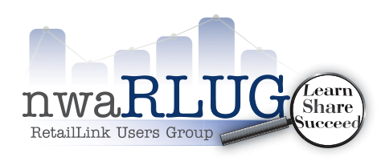

REMINDER -- Thursday
October 17th, 2018 --- 2:00 PM - 4:00 PM
New Tools for Shipper Creation
Item File
GBS Team
Usage of the Accounts Payable Chat Box

Meeting Location
NWACC Shewmaker Center,
Walmart Auditorium
1000 SE Eagle Way, Bentonville AR 72712

Introductions & Announcements at 2:00 PM
Tim Gorman, Corelle Brands
Rhonda Evans, Massimo Zanetti , Eileen Wilkerson, Big Time Products
Presentation 2:05 PM - 4:00 PM
Hosted by: nwaRLUG

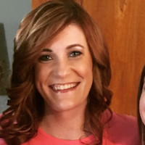
Sam Lynch
Sr. Project Manager, Walmart Stores, Inc.
Business Solutions –Item File

Vanessa Benshoff
Sr. Project Manager, Walmart Stores, Inc.
Business Solutions Item File
Omni Item Setup Process Update

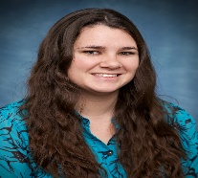
Lindsey Garrett
Business Solutions Item File
Omni Shipper Item Setup Process Update
 John Davis
Business Solutions Item File
Timeline for Item File System Updates
Introductions to Shared Item Setup

Upcoming Meeting Dates:
www.nwaRLUG.org
nwaRLUG:
We are a diverse group dedicated to shared experiences that benefit the Walmart Supplier Community. As members of the Northwest Arkansas RLUG it is our goal to define, communicate, and share the constantly changing needs of the retail community with our membership, Walmart and Sam's’Club. We succeed through sharing...

Monthly Chapter Meeting held on the third Thursday of the month
For all other meeting times and dates visit www.nwaRLUG.org

nwaRLUG Membership Dues are now being accepted for the 2018 Calendar Year
Annual dues are due on or before March 30th ^{e}ach calendar year. The $75 membership fee covers all employees of your company with a Retail Link User ID . The Company nwaRLUG Membership enables all associates within your company (with a current valid Retail Link User ID) to attend all monthly chapter meetings as well as all of our subgroup meetings. Dues can be paid online or at the nwaRLUG Monthly Chapter Meeting.
www.nwaRLUG.org

John Davis

